Project Report
Implement Client Script & UI Policy (Incident)

Platform | ServiceNow
Team ID | SWTID-2026-8713
Date | 03-10-2026
Duration | 5 hours 15 minutes (7 milestones)

Contents
1. Introduction 3
1.1 Project Overview 3
1.2 Purpose 3
2. Ideation Phase 3
2.1 Problem Statement 3
2.2 Empathy Map Canvas 3
2.3 Brainstorming 4
3. Requirement Analysis 4
3.1 Customer Journey Map 4
3.2 Solution Requirement 4
3.3 Data Flow Diagram 5
3.4 Technology Stack 5
4. Project Design 6
4.1 Problem Solution Fit 6
4.2 Proposed Solution 6
4.3 Solution Architecture 6
5. Project Planning & Scheduling 6
5.1 Project Planning 6
6. Functional and Performance Testing 7
6.1 Performance Testing 7
7. Results 8
7.1 Output Screenshots 8
8. Advantages & Disadvantages 9
9. Conclusion 9
10. Future Scope 9
11. Appendix 9
Source Code 9
Dataset Link 10
GitHub & Project Demo Link 10

1. Introduction

1.1 Project Overview
This project implements Client Scripts and UI Policies on the ServiceNow Incident form. UI Policies make selected fields mandatory, read-only or visible when defined conditions are met, and Client Scripts (onLoad, onChange and onSubmit) handle dynamic interaction and validation in the browser. The form reacts immediately to what the user does, without having to be submitted, so Incident records are more complete and consistent.

1.2 Purpose
The purpose is to show how UI Policies and Client Scripts work together to guide users on the Incident form: required information is captured, protected fields cannot be edited when they should not be, and unnecessary fields are hidden. The result is better data quality, less rework and a clearer form for service desk agents.

2. Ideation Phase

2.1 Problem Statement
The Incident form does not automatically enforce the required field behavior for every condition. Users may leave important fields incomplete, edit fields that should be protected, or see fields that are not needed. The administrator needs to configure fields to become mandatory, read-only or visible when defined conditions are met, and the developer needs rules that are clear, tested and free of conflicts.
PS | I am (Customer) | I'm trying to | But | Because | Which makes me feel
PS-1 | A ServiceNow administrator responsible for the Incident form | Configure Incident fields to become mandatory, read-only, or visible when defined conditions are met | Users may leave important fields incomplete or edit fields that should be protected | The form does not automatically enforce the required field behavior for every condition | Concerned about inconsistent Incident data and manual checking
PS-2 | A ServiceNow developer who configures Client Scripts and UI Policies | Implement dynamic client-side behavior for Incident fields | Rules can become inconsistent or conflict if they are not clearly defined and tested | Different Incident states and field values require different form behaviors | Uncertain about whether the form will respond correctly to every user action
PS-3 | A service desk agent / end user | Create and update Incident records using a clear and consistent form | I may not know which fields are required, editable, or relevant at a particular time | Field behavior is not dynamically controlled according to Incident conditions | Confused and frustrated

2.2 Empathy Map Canvas
User: ServiceNow administrator / developer.
SEES | SAYS AND DOES
• Incident fields that may be left incomplete  • Fields that remain editable when they should be protected  • Unnecessary fields displayed for every condition  • Inconsistent data-entry practices between Incident records | • Creates or updates Incident records  • Changes fields such as State, Category, Subcategory and Assignment Group  • Expects fields to become mandatory, read-only or visible when conditions are met  • Uses the form without needing to submit it to trigger field behavior

PAIN | GAIN
• Missing required Incident information  • Users can edit fields that should be protected  • Too many irrelevant fields make the form confusing  • Manual validation increases the chance of inconsistent data | • Required information is captured consistently  • Restricted fields become read-only when appropriate  • Relevant fields are shown based on Incident conditions  • Better user experience and more accurate Incident records

2.3 Brainstorming
The team considered several ways to control the Incident form and compared them.
Idea | Pros | Cons | Decision
Train agents and check data manually | No configuration needed | Errors still occur; wrong data is found only after saving | Rejected
UI Policies for mandatory, read-only and visible fields | Easy to build without code; reverses automatically | Cannot handle complex logic alone | Selected
Client Scripts (onLoad, onChange, onSubmit) | Form reacts instantly; supports validation and messages | Need testing; errors are harder to trace | Selected
Server-side validation only | Works for every channel | User gets feedback only after the save is attempted | Not selected for this project

Ideas were grouped into Mandatory Control, Read-only Control, Visibility Control, Dynamic Interaction and Validation & Testing, and prioritised so that field control comes first, followed by Client Script interaction and testing.

3. Requirement Analysis

3.1 Customer Journey Map
Stage | User action | Experience | Outcome
Entice | Agents complain that the form is confusing; administrator finds missing close notes | Awareness of the problem | Need for form rules is clear
Enter | Opens the Incident form, Client Scripts and UI Policies modules; identifies fields to control | UI Policies are easy to build; unsure when to use a Client Script | Fields and conditions listed
Engage | Adds UI Policy actions and writes onLoad, onChange, onSubmit scripts using g_form | The form reacts straight away when a field changes | Rules configured
Exit | Verifies each rule for every State, Category and Priority; checks the console | Confidence that mandatory and read-only rules work | Form cannot be saved with invalid data
Extend | Documents the outcome; reuses the patterns; updates rules when fields change | Fewer corrections and follow-up questions | Cleaner, more complete records

3.2 Solution Requirement
ID | Requirement | Type
FR-1 | UI Policies with conditions: mandatory, visible and read-only actions, reversed when the condition no longer applies | Functional
FR-2 | onLoad Client Script that sets the initial form state and shows guidance | Functional
FR-3 | onChange Client Scripts on Category, State, Impact and Urgency that update dependent fields | Functional
FR-4 | onSubmit Client Script that validates data and stops an invalid save | Functional
FR-5 | Field messages, form info messages and alerts for invalid entries | Functional
FR-6 | Test each rule for every State and Category and check the browser console | Functional
FR-7 | Activate, deactivate and update policies and scripts | Functional
NFR-1 | Usability – only relevant fields are shown, mandatory fields are clearly marked | Non-functional
NFR-2 | Security – client rules guide users; access is enforced on the server by roles and ACLs | Security
NFR-3 | Reliability – the same field values always give the same behavior | Non-functional
NFR-4 | Performance – rules run in the browser and avoid synchronous server calls | Non-functional
NFR-5 | Availability – rules are delivered with the form from the ServiceNow cloud instance | Non-functional
NFR-6 | Scalability – patterns can be reused for other tables; rules move with update sets | Non-functional

3.3 Data Flow Diagram
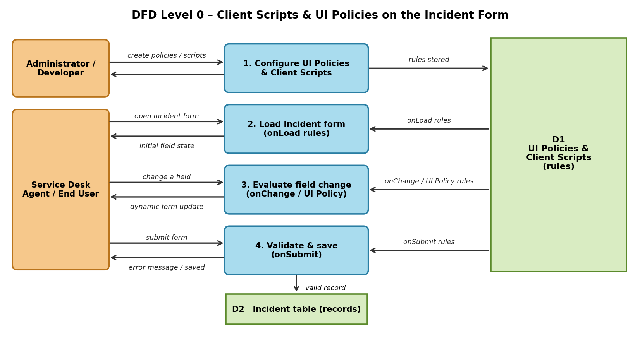
Figure: DFD Level 0 – Client Scripts & UI Policies on the Incident form

3.4 Technology Stack
Layer | Technology
Platform | ServiceNow cloud instance
User interface | ServiceNow Platform UI – Incident form (HTML, CSS, JavaScript in the browser)
Form rules | UI Policies (sys_ui_policy) with Execute if true / false scripts
Scripting | Client-side JavaScript – Client Scripts (sys_script_client) using g_form and g_user
Data store | Incident table (incident)
Security | Roles and ACLs (server-side); Impersonate User for testing
Testing | Incident form, browser developer console and a timer

4. Project Design

4.1 Problem Solution Fit
Problem | Solution fit
Important fields are left incomplete | UI Policy makes Close code, Close notes and Short description mandatory when conditions are met
Users edit fields that should be protected | UI Policy makes fields read-only for closed incidents
Unnecessary fields shown for every condition | UI Policy shows or hides fields such as On hold reason by State and Category
Bad data is found only after the incident is saved | onChange and onSubmit Client Scripts react instantly and block invalid saves with a clear message

4.2 Proposed Solution
Use a combined Client Script and UI Policy approach on the Incident table. UI Policies control mandatory, read-only and visible behavior when defined conditions are met, while Client Scripts handle dynamic client-side interactions that need additional logic.
Rule type | Runs | Used for
UI Policy | When its condition is true / false | Mandatory, read-only and visible fields
Client Script – onLoad | When the form opens | Initial state and guidance messages
Client Script – onChange | When a field value changes | Updating dependent fields and field messages
Client Script – onSubmit | When the user saves | Validating data and stopping an invalid save

4.3 Solution Architecture
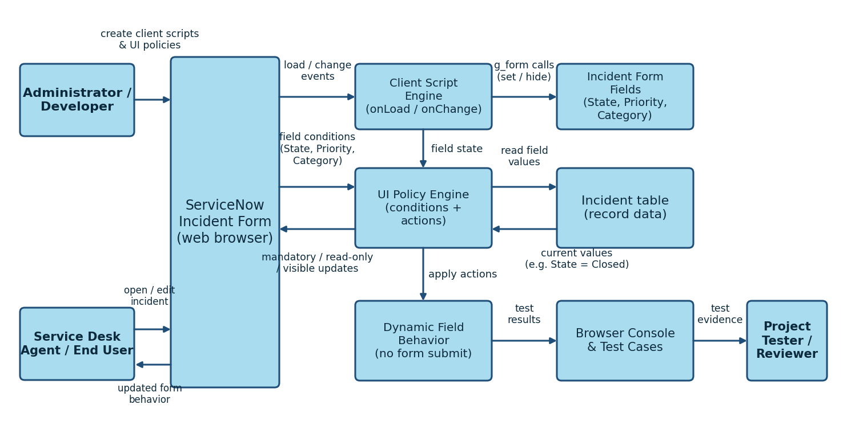
Figure: Solution architecture – Client Scripts and UI Policies on ServiceNow

5. Project Planning & Scheduling

5.1 Project Planning
The project is planned as seven milestones (5 hours 15 minutes in total) and three sprints of 10 days each, with 30 story points.
Milestone | Activity | Owner | Duration | Status
Milestone-1 | Identify Incident fields and conditions | Vishal | 30 min | To do
Milestone-2 | Configure UI Policy to make selected fields mandatory | Thabeshwin | 45 min | To do
Milestone-3 | Configure UI Policy to make selected fields read-only | Thabeshwin | 45 min | To do
Milestone-4 | Configure UI Policy to show/hide selected fields | Supriya | 45 min | To do
Milestone-5 | Implement dynamic Incident field behavior | Supriya | 1 hr | To do
Milestone-6 | Test conditions, field behavior and user actions | Sakthivel S | 1 hr | To do
Milestone-7 | Document project outcome and verify consistent data entry | Sakthivel S | 30 min | To do
Total |  |  | 5 hrs 15 min

Sprint | Start | End (planned) | Story points
Sprint-1 | 05 Oct 2026 | 16 Oct 2026 | 10
Sprint-2 | 19 Oct 2026 | 30 Oct 2026 | 12
Sprint-3 | 02 Nov 2026 | 13 Nov 2026 | 8

6. Functional and Performance Testing

6.1 Performance Testing
10 functional and 3 performance test cases are defined. Performance acceptance criteria: the form loads in under 3 seconds and fields react in under 1 second. Actual results and status are recorded by the tester while executing the tests.
Test ID | Scenario | Expected result | Status
FT-01 | Short description mandatory | Short description is marked mandatory and the incident is not saved until it is filled. | Pending
FT-02 | Close code / Close notes mandatory on Resolved | Close code and Close notes become mandatory immediately and the save is blocked until both are filled. | Pending
FT-03 | Mandatory rule reverses | Close code and Close notes are no longer mandatory; the form can be saved. | Pending
FT-04 | Show / hide On hold reason | On hold reason appears for On Hold and is hidden for other States without reloading the form. | Pending
FT-05 | Read-only fields on closed incident | The controlled fields are read-only and cannot be edited. | Pending
FT-06 | onLoad initial state and guidance | The form opens with the correct default state and shows the guidance message. | Pending
FT-07 | onChange updates dependent fields | Dependent fields update only when the user changes the source field, not while the form is loading. | Pending
FT-08 | onSubmit validation | Invalid data shows a clear message and the save is blocked; valid data is saved. | Pending
FT-09 | Activate / deactivate rules | The behavior stops when a rule is inactive and returns when it is active; other rules are unaffected. | Pending
FT-10 | No script errors | No JavaScript errors appear in the console for any rule. | Pending
PT-01 | Form Load Time | Form loads in under 3 seconds. | Pending
PT-02 | Field Change Response | Fields react immediately (under 1 second) without reloading the form. | Pending
PT-03 | Many Rules on One Form | No slowdown, no conflicting rules and the same values always give the same behavior. | Pending

7. Results

7.1 Output Screenshots
The expected form behavior for each State is as follows.
State | Close code / Close notes | On hold reason | Editable fields | Message shown
New / In Progress | Optional | Hidden | Yes | Guidance on load
On Hold | Optional | Visible | Yes | Select the hold reason
Resolved | Mandatory | Hidden | Yes | Close fields required
Closed | Mandatory | Hidden | Read-only (controlled fields) | Incident is closed

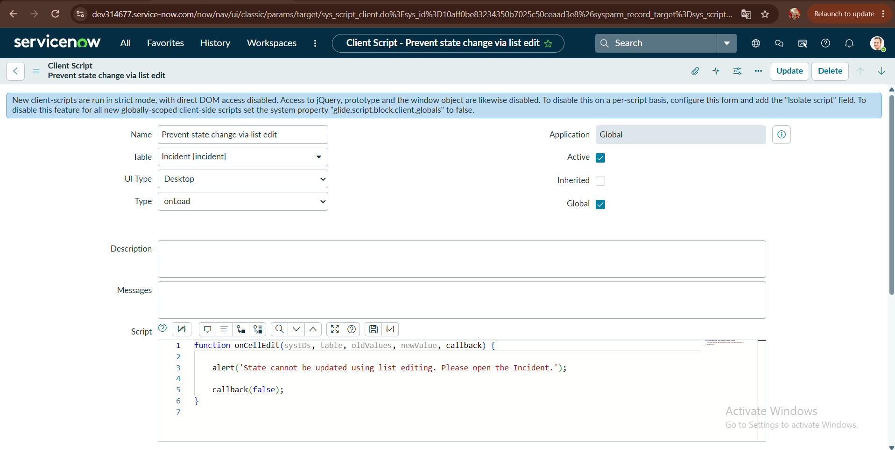

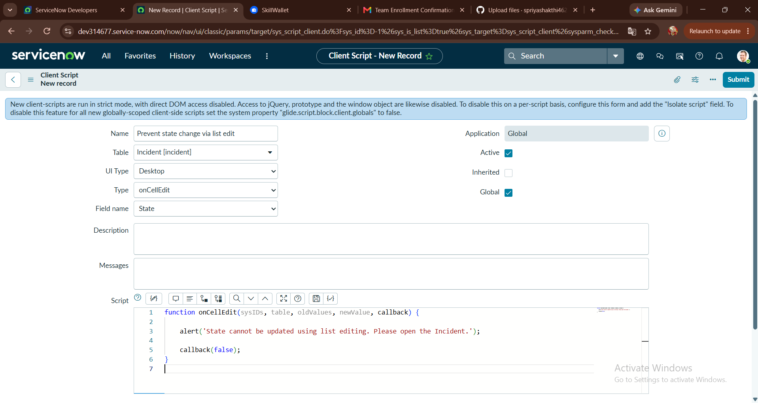

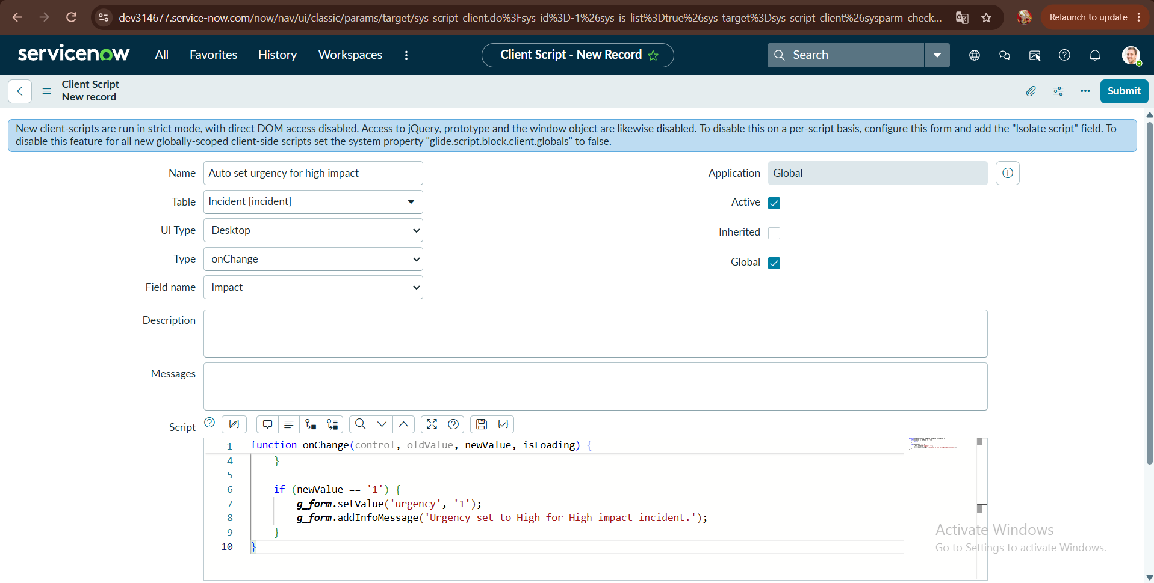

8. Advantages & Disadvantages
Advantages | Disadvantages
• The form reacts instantly, without submitting  • Required data is captured consistently  • Relevant fields only – a shorter, clearer form  • UI Policies need little or no code  • Patterns are reusable for other forms | • Rules run only in the browser form, not for API or import updates  • Not a security control – ACLs are still needed  • Conflicts are possible between policies and scripts  • Scripts need maintenance when fields change  • Too many rules can make the form harder to manage

9. Conclusion
The project shows how UI Policies and Client Scripts can control the ServiceNow Incident form dynamically. UI Policies make fields mandatory, read-only or visible when conditions are met, and onLoad, onChange and onSubmit Client Scripts add guidance, dependent-field updates and validation. Together they give users clear, immediate feedback and help produce complete and consistent Incident records. The test results from Section 6 should be added here once the tests have been executed.

10. Future Scope
- Add Data Policies or Business Rules to enforce the same rules for API and import updates.
- Apply the same patterns to other forms such as Problem and Change.
- Move the rules between instances with update sets.
- Automate verification using the Automated Test Framework.
- Extend the rules to Service Portal and mobile forms.

11. Appendix

Source Code
onChange Client Script – State (Table: incident):
function onChange(control, oldValue, newValue, isLoading, isTemplate) {
// Do nothing while the form is loading or when the value is cleared
if (isLoading || newValue === '') {
return;
}
// Resolved (6) or Closed (7): remind the user about the closure fields
if (newValue == '6' || newValue == '7') {
g_form.showFieldMsg('close_notes', 'Close code and Close notes are required.', 'info');
} else {
g_form.hideFieldMsg('close_notes', true);
}
// On Hold (3): guide the user to the hold reason
if (newValue == '3') {
g_form.showFieldMsg('hold_reason', 'Select why the incident is on hold.', 'info');
}
}

onSubmit Client Script (Table: incident):
function onSubmit() {
var state = g_form.getValue('state');
var shortDesc = g_form.getValue('short_description').trim();
if (shortDesc === '') {
g_form.showFieldMsg('short_description', 'Short description is required.', 'error');
return false; // stop the save
}
if ((state == '6' || state == '7') && g_form.getValue('close_notes').trim() === '') {
g_form.showFieldMsg('close_notes', 'Close notes are required to resolve or close.', 'error');
return false; // stop the save
}
return true; // data is valid, allow the save
}

Dataset Link
No external dataset was used. Sample Incident records were created manually with different States and Categories.

GitHub & Project Demo Link
GitHub: https://github.com/<username>/<repository>
Demo: https://<your-demo-link>
(replace with your own links)

